**Name:** Satish Kumar Sharma.

**BITS ID:** 2022MT93327

**Subject:** Open Source Software Engineering

**Subject Code:** SEZG587

**Q. Use cases of Moodle. Understanding Open-source project.**

* **Moodle** 
  + Introduction and History
  + Managing a Moodle site
  + Managing a Moodle course
  + Managing content

**Answer**: I have chosen Moodle as the subject for my assignment.

Table of Contents

* **Moodle** 
  + Introduction and History
  + Managing a Moodle site
  + Managing a Moodle course
  + Managing content
  + Benefits of Moodle

1. **Introduction and History of Moodle:**

**Introduction to Moodle:**

Moodle, which stands for Modular Object-Oriented Dynamic Learning Environment, is an open-source learning management system (LMS) designed to provide educators, administrators, and learners with a single platform for creating and delivering online educational content. Moodle is known for its flexibility, customization options, and support for a wide range of educational activities.

**Where it all began: A remote town in Western Australia**

As a young boy, Moodle’s Founder and CEO, Martin Dougiamas, lived nearly 1000 kilometres from the nearest school in a remote area of the Western Australian desert. This was in the 1970s, long before computers were a household item or readily accessible to students. To pursue his education, Martin’s family registered him into the School of Air – learning delivered through shortwave radio, the best available technology at the time. This experience with distance learning sowed the seeds of Martin’s vision to use the Internet to:

Take education beyond physical classrooms that have barely changed in hundreds of years

Enable quality education in all corners of the globe

Coupled with this vision is Martin’s support of the United Nations Universal Declaration of Human Rights that everyone has the right to education. To break the barriers faced by millions in accessing education, **Martin founded Moodle with the goal of creating an online learning solution that is flexible to learner’s needs, accessible, and would provide a quality education for all.**

**Objectives of this document:**

1. The foremost objective of the research is to understand in detail how a learning management system operates by selecting Moodle as LMS.
2. To explore the various activities which can be performed in the Moodle.
3. To know the benefits of Moodle for faculty as well as the students.
4. To give suggestions for the overall engrossment of all the users with the LMS.

**History of Moodle:**

Moodle was created by Martin Dougiamas, an Australian educator and computer scientist. The development of Moodle began in 1999 when Dougiamas was working on his Ph.D. at Curtin University in Western Australia. He wanted to create a platform that would support constructivist pedagogy—an approach to teaching and learning that emphasizes active participation and collaboration.

Here is a brief timeline of key milestones in the history of Moodle:

History: <https://docs.moodle.org/403/en/History>

Growing up in the Australian outback in the late 1970s, Moodle's Founder and Lead Developer Martin Dougiamas took lessons from the School of the Air, giving him from a young age an insight into distance learning.

As an adult, he worked and later studied at Curtin University, where his experience with WebCT prompted him to investigate an alternative method of online teaching. In 1999 he started trialling early prototypes of a new LMS, the experiences of which formed the basis for his paper Improving the Effectiveness of online Learning. He registered the word 'Moodle' as a trademark of Moodle Pty Ltd and explained his choice of name in a forum post some years later.

Research continued: the first ever Moodle site was Peter Taylor's http://smec2001.moodle.com/ at Curtin University, with Martin making the first post on his own Moodle.com site in November 2001. The pair published An Interpretive analysis of an internet-based course constructed using a new courseware tool called Moodle.

By the end of 2001, Moodle could be downloaded via CVS (Git arrived in 2010 and replaced CVS in 2013) and basic installation documentation was available. It was still very much one man's vision, with Martin setting up the tracker in May 2002 "so you can see what I am working on."

**Moodle 1.0** was released in August 2002. Users were discussing Moodle on a new forum, translating Moodle into different languages and creating themes. A year later, the first contributed module (workshop) was released and Moodle.org became the community arm of Moodle, with Moodle.com representing the commercial aspect.

Moodle grew quickly: the first ever Moodle Moot was held in Oxford in 2004 and companies started applying to become Moodle partners. 2005 marked the move to dedicated premises with Martin and 4 others; the current HQ at Richardson St West Perth, houses 16 with 11 working remotely. At the Spanish Moodle Moot 2005 in Las Palmas de Gran Canaria, the mojito established itself as the unofficial - and then subsequently official - Moodle Moot drink. (See blog post: Moodle Mojitos History)

With improved documentation and new certification, Moodle had established itself by 2007 as a leading and award-winning open source LMS. From 1000 registered sites in 2004, it had gone to half a million users in 2008 and over a million users in 2010, with over 50 Moodle partners. Its translation repository AMOS held over 100 languages. The long-awaited Moodle 2.0 came out in November 2010 and now, regular releases bring enhanced features every six months. The current focus is on mobile technology: an official HTML5 app was released in 2013 and Moodle includes a customizable theme suitable for all screen sizes.

The inauguration of the Moodle Research conference in 2012 served as a reminder that, however advanced the technology, Moodle design and development is guided by social constructionist pedagogy. During September 2013, the official Moodle MOOC, Learn Moodle, introduced over 9000 participants to Moodle's basic features. Educators everywhere are encouraged to share their experiences, just as did Martin over a decade previously. The MOOC was repeated in January 2015 and is now run on a regular, six monthly basis. During 2020 free self-paced courses were added to Learn Moodle to help new teachers, administrators and developers.

In July 2015, alongside a major redesign of Moodle.com, a new initiative was announced: **MoodleCloud** offering free, HQ-managed hosting.

Throughout 2016, HQ worked on improving Moodle’s User experience (UX) by forming the first UX team and also releasing a fresh new default theme - the Boost theme.

By 2017, statistics on Moodle.net indicated there were over 100 million registered users for Moodle. During 2017, a number of projects were developed, including:

* Working on and integrating an open source solution to learning analytics - Project Inspire
* Spreading **MoodleMoot** events into many more countries around the world
* Establishing the first Education team
* Re-affirming Moodle's mission of empowering educators to improve our world
* Releasing Moodle Desktop

In late 2017, Moodle received a significant 'angel' investment, fueling growth and innovation. The journey with the community, Partners and global users will be an exciting one, as Martin shared in his MoodleMoot Australia 2017 keynote.

The first Global MoodleMoot took place in Barcelona in November 2019.

In March 2020, registered users passed 190 million on over 145,000 sites.

1. **2001: Moodle 1.0 was released**. It included features for creating courses, quizzes, forums, and other educational activities. The release marked the official launch of Moodle as an open-source project.
2. **2004: Moodle 1.5 introduced** significant improvements, including the addition of the roles and capabilities system, allowing for more fine-grained control over user permissions.
3. **2008: Moodle 1.9 brought further enhancements**, including improvements to the user interface, gradebook, and support for new question types in quizzes.
4. **2010: Moodle 2.0 represented a major upgrade**, introducing a more modular architecture, improved navigation, and support for new activities and resources.
5. **2013: Moodle 2.7 introduced a responsive design**, making the platform more accessible across different devices. This release also focused on improving usability.
6. **2017: Moodle 3.4 included features** such as the integration of Competency-Based Education (CBE) frameworks and improvements to the user interface.
7. **2020: Moodle 3.9 introduced enhancements** to improve user experience, particularly in the areas of assignment grading and forum discussions. It also included updates to boost performance.
8. **Present: Moodle continues to evolve with regular releases**, with ongoing improvements in usability, accessibility, and the introduction of new features based on user feedback.

In March 2020, registered users passed 190 million on over 145,000 sites.

In May 2020, the Moodle Educator Certification program was launched, to certify experienced Moodle-using teachers, and progress was made on a new resource-sharing site MoodleNet

**Key Features of Moodle:**

* **Course Management:** Moodle provides a platform for organizing and managing courses, including the ability to create and organize content, set assignments, and manage assessments.
* **Collaboration Tools:** Moodle offers a variety of collaboration tools, such as discussion forums, wikis, and chat, to facilitate interaction and engagement among learners.
* **Customization:** Educators can customize the look and feel of their Moodle courses, adapting them to fit their specific needs and preferences.
* **Open Source:** Moodle's open-source nature allows institutions and developers to modify, extend, and contribute to its codebase.
* **Extensibility:** Moodle supports a wide range of plugins and extensions, allowing institutions to add new features and integrate with other systems.
* **Community Support:** The Moodle community is active and engaged, providing support, documentation, and sharing resources through forums and collaborative efforts.

Overall, Moodle has become a widely used and respected platform in the e-learning and educational technology space, serving a diverse range of educational institutions, businesses, and organizations globally.

1. **Managing a Moodle site**

**Managing a Moodle site:**

Managing a Moodle site involves a range of tasks related to the setup, configuration, administration, and ongoing maintenance of the Moodle learning management system (LMS). Here is a guide on managing a Moodle site:

**1. Installation and Setup:**

System Requirements: Ensure that your server meets the minimum requirements for hosting Moodle. This includes having a web server, a database server, and PHP installed.

Download and Install: Download the latest version of Moodle from the official website. Follow the installation instructions provided in the Moodle documentation.

> If the institution wants to make their own Moodle, then the prerequisites are –

•  Apache2.x+, MariaDB 5.5.30+, PHP 5.4.4+

•  These can be installed separately or by using a Web server distribution like XAMPP.

Outline:

**System requirements for installing Moodle**

* + Check for XAMPP
  + PHP version check
  + MySQL (MariaDB) version check
  + Solve the error message "Unable to connect" and start XAMPP service
  + Solve the error message "Command not found" and start XAMPP service
  + Solve the error message “An apache daemon is already running” and start XAMPP service
  + Solve the error message "MySQL daemon failed to start" and start XAMPP service
  + Create a user and database for Moodle

**Success confirmation message**

By the above two processes institutions can make their own website.

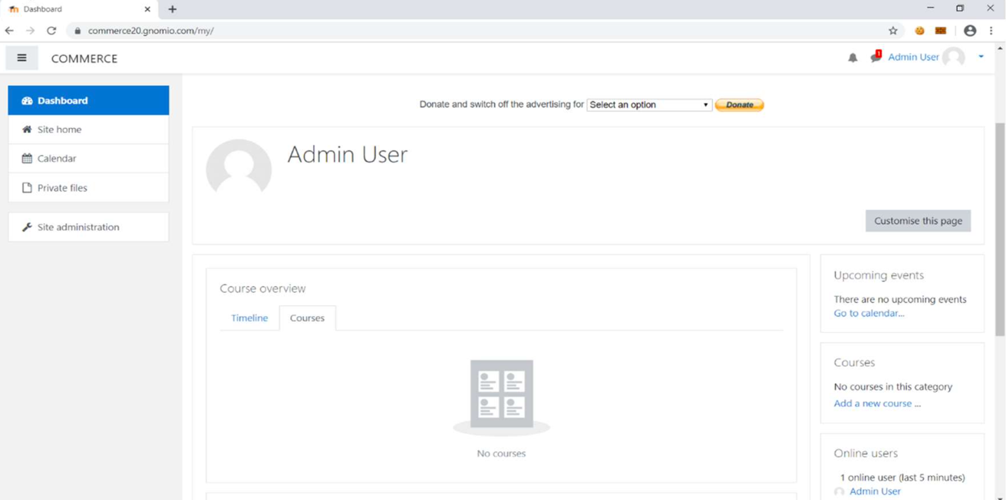

**2. Site Configuration:**

* **Site Settings:** Configure general site settings, including site name, description, and default language. These settings can be adjusted in the "Site administration" section.
* **Authentication:** Set up authentication methods for user access. Moodle supports various authentication methods such as email, manual accounts, LDAP, and more.
* **Enrollment Methods:** Define how users can enroll in courses. Moodle offers various enrollment methods, including self-enrollment, manual enrollment, and cohort enrollment.

**3. Course Management:**

* **Create Courses:** Set up courses based on the curriculum. Add course details, resources, and activities using the course editing features.
* **Assign Roles:** Define roles for users (e.g., teacher, student, administrator) and assign appropriate permissions. Roles can be customized based on the user's responsibilities.
* **Gradebook Setup:** Configure the gradebook settings, grading scales, and assessment methods for courses.

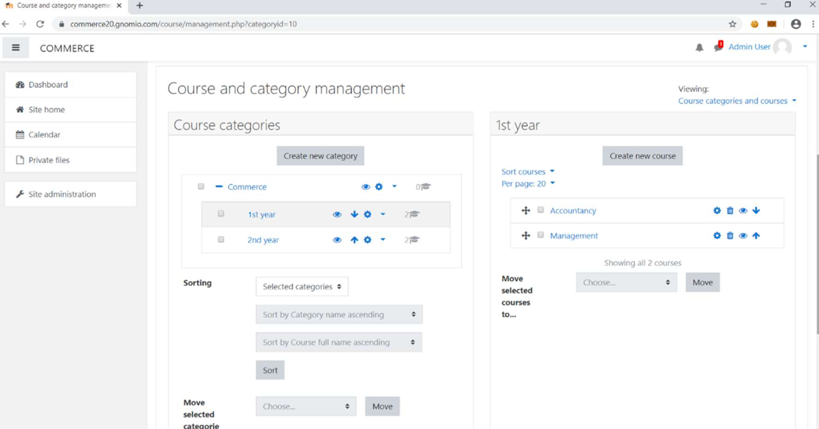

Fig: The page above showcases the categories and courses established by the site administrator. Within the commerce category, there are two subcategories: 1st year and 2nd year. Accountancy and management.

**4. User Management:**

* **User Accounts:** Manage user accounts, including creating, deleting, and updating accounts. Users can be manually added or imported using CSV files.
* **Groups and Cohorts:** Organize users into groups and cohorts to facilitate course management and communication.
* **User Roles:** Assign roles and permissions to users based on their responsibilities in the Moodle site.

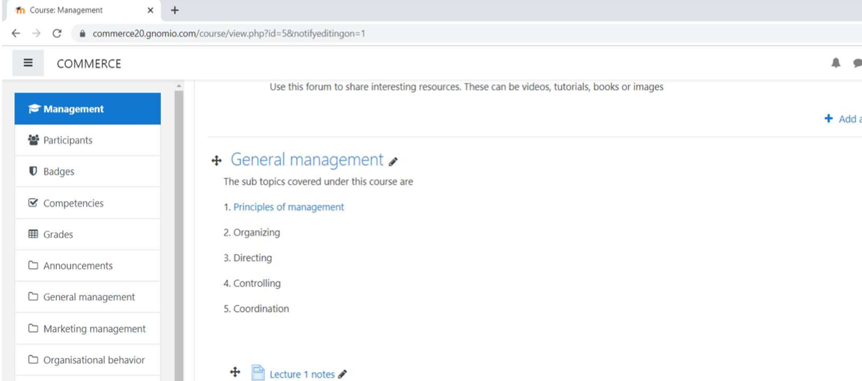

**5. Plugin Management:**

* **Install Plugins:** Extend Moodle's functionality by installing plugins. These can include additional activity modules, themes, and authentication methods.
* **Update Plugins:** Regularly check for updates to installed plugins and update them to the latest versions to ensure security and compatibility.

**6. Security and Privacy:**

* **Security Settings:** Implement security best practices, such as using secure URLs (HTTPS), setting appropriate permissions, and configuring secure login methods.
* **Privacy Settings:** Comply with privacy regulations by configuring privacy settings and obtaining user consent for data processing.

**7. Backups and Maintenance:**

* **Regular Backups:** Schedule regular backups of the Moodle site, including the database and files. Store backups in a secure location.
* **Updates:** Keep the Moodle software up to date by applying regular updates and patches. Check for new releases on the Moodle website.
* **Monitoring:** Monitor server performance, user activity, and error logs to identify and address any issues promptly.

**8. Support and Community:**

* **Community Forums:** Participate in Moodle community forums to seek advice, share experiences, and stay informed about updates and best practices.
* **Documentation:** Refer to the official Moodle documentation for detailed information on managing and configuring the Moodle site.

By effectively managing these aspects, administrators can create a secure, well-organized, and efficient learning environment for users within the Moodle site. Regular monitoring, maintenance, and engagement with the Moodle community contribute to the overall success of the platform.

1. **Managing a Moodle course**

**Managing a Moodle course:**

Managing a Moodle course involves various tasks related to course creation, organization, communication, assessment, and ongoing maintenance.

Here's a guide on managing a Moodle course:

**1. Course Creation and Setup:**

* Create a New Course: In the Moodle site administration, navigate to "Site administration" > "Courses" > "Manage courses and categories" to create a new course.

-Enter essential details such as the course name, description, and format.

* Configure Course Settings: Access the course settings to configure options such as enrollment methods, visibility, and guest access.

-Set up course formats (weekly, topics, social) based on your preferred structure.

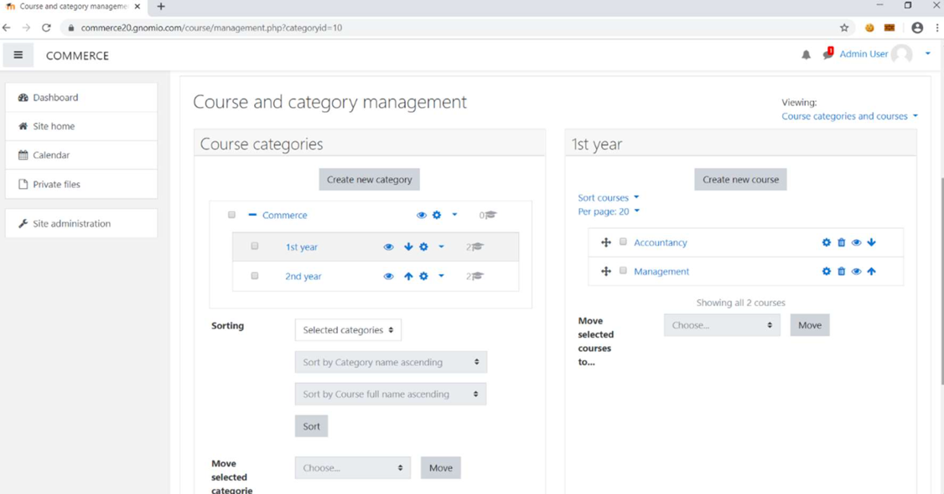

**2. Course Content:**

* **Add Resources:** Use the course editing features to add resources such as files, URLs, books, and pages.Organize resources in a logical order within sections.
* **Create Activities:** Incorporate interactive activities like assignments, quizzes, forums, and surveys to engage learners.Configure activity settings, including grading options, due dates, and access restrictions.
* **Set Up Forums:** Enable discussion forums for communication and collaboration.Configure forum settings, including subscription options and permissions.

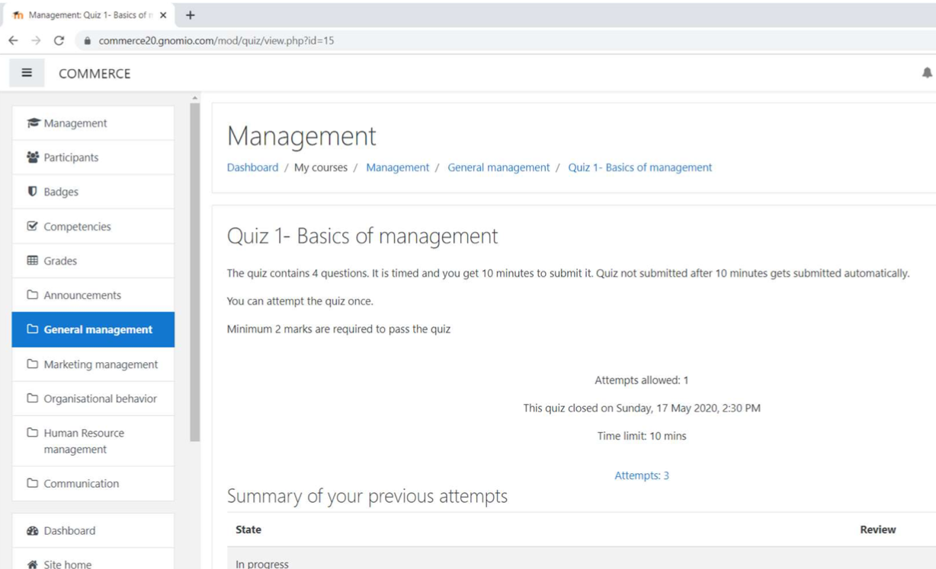

**3. User Enrollment and Management:**

* **Enroll Users:** Enroll users manually or set up self-enrollment and cohort enrollment options. Assign roles to users based on their responsibilities in the course.
* **Manage Groups:** Create groups for collaborative work or to differentiate content delivery. Assign students to specific groups and use group activities.

**4. Assessment and Grading:**

* **Set Up the Gradebook:** Configure the gradebook to align with your assessment structure. Add grade items and categories as needed.
* **Create Assignments and Quizzes:** Design assignments and quizzes with clear instructions. Configure grading criteria, rubrics, and submission settings.
* **Provide Feedback:** Utilize the grading features to provide feedback to learners. Encourage peer review and self-assessment when appropriate.

**5. Communication:**

* **Announcements:** Use the announcement forum or the Moodle News forum to communicate important information to all course participants.
* **Messaging and Notifications:** Encourage the use of Moodle messaging for direct communication between users. Configure notification settings to keep users informed about updates and activities.

**6. Monitoring and Analytics:**

* **Course Reports:** Access course reports to monitor user activity and engagement. Analyze logs, participation, and completion reports to gain insights.
* **User Progress:** Review individual user progress through the user profile and gradebook. Identify and support learners who may need additional assistance.

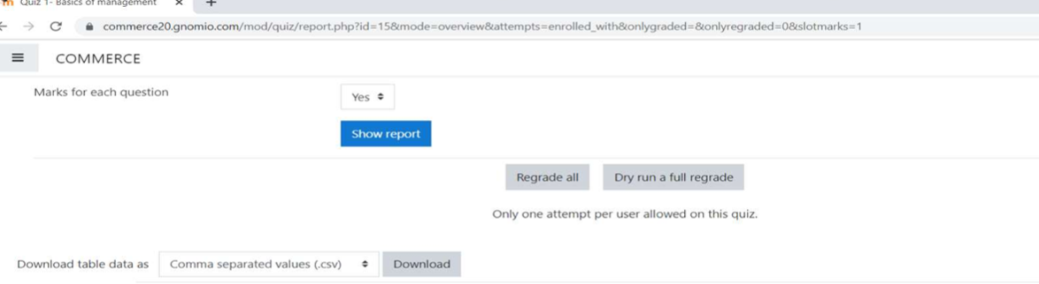

**7. Accessibility and Usability:**

* **Ensure Accessibility:** Create content that adheres to accessibility standards to ensure all learners can access and engage with the course materials.
* **User-Friendly Navigation:** Design the course with clear navigation and user-friendly interfaces. Provide instructions and guidance for using course features.

**8. Backups and Course Duplication:**

* **Backup and Restore:** Regularly backup course content to prevent data loss. Restore courses as needed, especially when reusing content across semesters.
* **Duplicate Courses:** Use the course duplication feature to create new courses based on existing content.

**9. Continuous Improvement:**

* **Collect Feedback:** Gather feedback from learners through surveys, forums, or other means. Use feedback to make improvements to course design and content.
* **Update Content:** Regularly review and update course content to reflect changes in the curriculum or to enhance the learning experience.

By effectively managing these aspects, instructors and administrators can create and maintain a well-organized, engaging, and effective Moodle course. Regular communication, monitoring, and the use of available analytics contribute to the success of the course and the overall learning experience for participants.

1. **Managing content**

**Managing content:**

Managing content in Moodle involves creating, organizing, and updating educational materials within courses.

Here are the key steps for managing content in Moodle:

**1. Adding Resources:**

* **Upload Files:** Use the "File" resource to upload documents, presentations, or any other files. This is a simple way to share static content.
* **Link to URLs:** The "URL" resource allows you to link directly to external websites or online resources. This is useful for integrating content from various sources.
* **Embed Media:** Moodle supports the embedding of multimedia content. You can embed videos, audio files, or interactive media using the appropriate resource types.
* **Create Pages:** Use the "Page" resource to create HTML pages within Moodle. This is useful for presenting information in a structured and visually appealing way.
* **Add Books and Wikis:** Moodle provides resources like "Book" and "Wiki" that allow you to create structured content with chapters or collaborative content created by learners.

**2. Organizing Content:**

* **Use Sections:** Divide your course content into sections to organize it logically. Sections help learners navigate through the material.
* **Topic Formats:** Choose a topic format that suits your course structure. Moodle offers options like weekly, topics, or social formats for presenting content.
* **Use Labels:** Labels can be added to sections or individual resources/activities to provide additional context or instructions.
* **Conditional Activities:** Use conditional activities to control when certain content becomes available to learners based on their completion of previous activities or conditions you set.

**3. Interactivity and Activities:**

* **Add Assignments:** Use the "Assignment" activity to create assessments, projects, or tasks for learners to submit. You can provide feedback and grades through the Moodle interface.
* **Create Quizzes:** The "Quiz" activity allows you to create quizzes with various question types. You can set up automatic grading and provide feedback.
* **Discussion Forums:** Utilize discussion forums to foster interaction and collaboration among learners. Forums are effective for asynchronous communication.
* **Glossaries and Databases:** Moodle offers activities like glossaries and databases for collaborative content creation and resource sharing among learners.

**4. Access Control and Availability:**

* **Set Access Restrictions:** Control access to content by setting restrictions based on conditions such as date, completion of activities, or grades.
* **Guest Access:** Decide whether to allow guest access to specific content. This is useful for providing a preview of the course to potential participants.
* **Use Groups:** If your course has multiple groups, use the group settings to control which content is visible to different groups of learners.

**5. Accessibility and Multimedia:**

* **Ensure Accessibility:** Create content that adheres to accessibility standards to ensure it is usable by all learners, including those with disabilities.
* **Multimedia Integration:** Enhance your content with multimedia elements such as images, videos, and audio to make it more engaging.

**6. Backup and Restore:**

* **Regular Backups:** Perform regular backups of your course content to prevent data loss. This is crucial for preserving your materials and activities.
* **Restore Courses:** Use the restore feature to duplicate courses or move content between different Moodle sites.

**7. Monitoring and Analytics:**

* **Course Reports:** Utilize course reports to monitor learner engagement, participation, and progress.
* **User Progress:** Review individual learner progress through the gradebook and user profile.

**8. Continuous Improvement:**

* **Collect Feedback:** Encourage learners to provide feedback on the content. Use surveys or forums to gather input.
* **Update Content:** Regularly review and update your content to ensure it remains accurate and relevant. This is particularly important in dynamic fields.

By following these steps, educators can effectively manage content in Moodle, providing a rich and interactive learning experience for participants. Regular updates, engagement with learners, and a focus on usability contribute to the success of the course.

**Benefits of Moodle:**

**Benefits to the teacher**

|  |  |  |
| --- | --- | --- |
| **Events** | **Manual working** | **Moodle working** |
| Conducting quiz and exams | Printing of paper and conducting exams takes around a month | Typing question paper and conducting online exams takes around 10 days for all the subjects |
| Live classes | Fixed as per the time table of the college | Flexible as teacher and student can coordinate and conduct live classes |
| Evaluation of answer sheet and quiz | Takes around a month | Almost instantly |
| Attendance | Teacher has to take attendance daily and maintain the record of the same | Attendance gets recorded by the login and logout time of the student. |

**Benefits to the student**

|  |  |  |
| --- | --- | --- |
| **Events** | **Manual working** | **Moodle working** |
| Lecture notes | Students have to note down or get it printed which involves time consuming and costly exercise | Student can access the lecture notes in their smartphone and download the same. |
| Syllabus | Students make a rigorous search to university's website or higher education' website | can be downloaded from my course |
| In case of not attending the class | Students have to depend upon other fellow mates | They can check |
| Anxiety of result | Exists and sometimes leads to depression | As grading completes in short time. The scope of anxiety is low |

**Suggestions:**

* The choice of Learning management system depends upon the requirements of the institute, so Moodle is just a reliable suggestive LMS option.
* The mind of any Learning management system is the faculty of the colleges. So, colleges should conduct workshops for faculties to make them understand their role.
* Availability of electricity and internet is a prerequisite. Institutions have to spend on infrastructure in order to get equipped with the Learning management system.
* The backbone of the Learning management system are the students. Student’s perception and acceptability for the LMS should be assessed in advance for the successful implementation.
* Colleges and institutes should make a comparison between various Learning management systems and service providers before finalizing the LMS.
* To ensure the use of LMS by every faculty, institutes should make an activity be it a quiz or assignment needs to be compulsory conducted through LMS.
* If the percentage of smartphone users (teachers and students) cross 80% then only LMS should be adopted. For the rest 20% institute should make an alternative arrangement within the campus.

**Limitations:**

The research is more conceptual in approach but for its implementation this needs to be evaluated in terms of the mindset and approach of colleges. To achieve this objective, primary research would be a supporting end. Moreover, a comparative analysis of various learning management systems can give a better insight on the utility and service of the LMS. The concepts of Moodle explained above are basic in nature as there are many different advance concepts which have not been taken into consideration due to time constraint.

**Conclusion:**

The institutions are having option to study from home and the institutions to be ready with various other accessories. For this Moodle Learning management system is the easiest way to overcome this challenge. World is moving towards digitalization so, digitalizing the course, tests, assignments is a good tool to make students technology and digitally literate. But before adapting the Moodle or other type of Learning management system, questions to be thought are: Will it be able to maintain the cordial relation and the two-way communication process between students and teachers? Would it make our students sit for long hours in front of screens and hinder their eyesight? Would the readymade course material impede the logical and evaluative mindset of the students? The implementation of the Learning management system lies upon the answers of above questions as these questions would affect the student’s development in a long run.

**References**

* Learning Management System in Higher Education. International Journal of Science Technology & Engineering, 2(3), 158-162. Retrieved May 21, 2020
* Spoken tutorial project. <https://spoken-tutorial.org/watch/Moodle+Learning+Management+System/Getting+Ready+for+Moodle+Installation/English/>
* Bits Pilani eLearning: https://elearn.bits-pilani.ac.in/user/courses/

Thank you